Web Development Services – Competitor Keyword Analysis

Report generated on August 14, 2025, 04:54

# 1. Objective

Analyze competitor pages related to Web Development Services to extract 2–4 word keyword phrases, classify them by tail type (2=short, 3=mid, 4=long), and evaluate basic metrics: search volume index, difficulty (derived from volume index), and CPC (demo values). Visualize competitor coverage and provide insights.

# 2. Data Sources & Fields

Dataset fields used:  
- keyword: extracted 2–4 word phrase  
- source_url: competitor page URL  
- competitor: competitor name  
- frequency: raw phrase frequency in text  
- tail_type: Short tail (2), Mid tail (3), Long tail (4)  
- volume_index: Google Trends popularity index (approximate)  
- difficulty: derived as an inverse function of volume  
- cpc_usd: demo CPC values (for visualization)

# 3. Normalization & Filtering Rules

Punctuation-only stopwords were applied (kept only punctuation list: , . ! ( ) [ ] { } " '). Text was lowercased; punctuation removed; tokens formed by splitting on whitespace/dashes/ampersands. Phrases were constructed as contiguous 2–4 token n-grams from page text.

# 4. High-Level Summary

Total rows: 421

Unique keywords: 412

Unique phrases per competitor:

|  |  |
| --- | --- |
| Competitor | Unique Phrases |
| Coalition Technologies | 110 |
| Digital Silk | 90 |
| Netguru | 83 |
| Americaneagle.com | 75 |
| CMARIX | 63 |

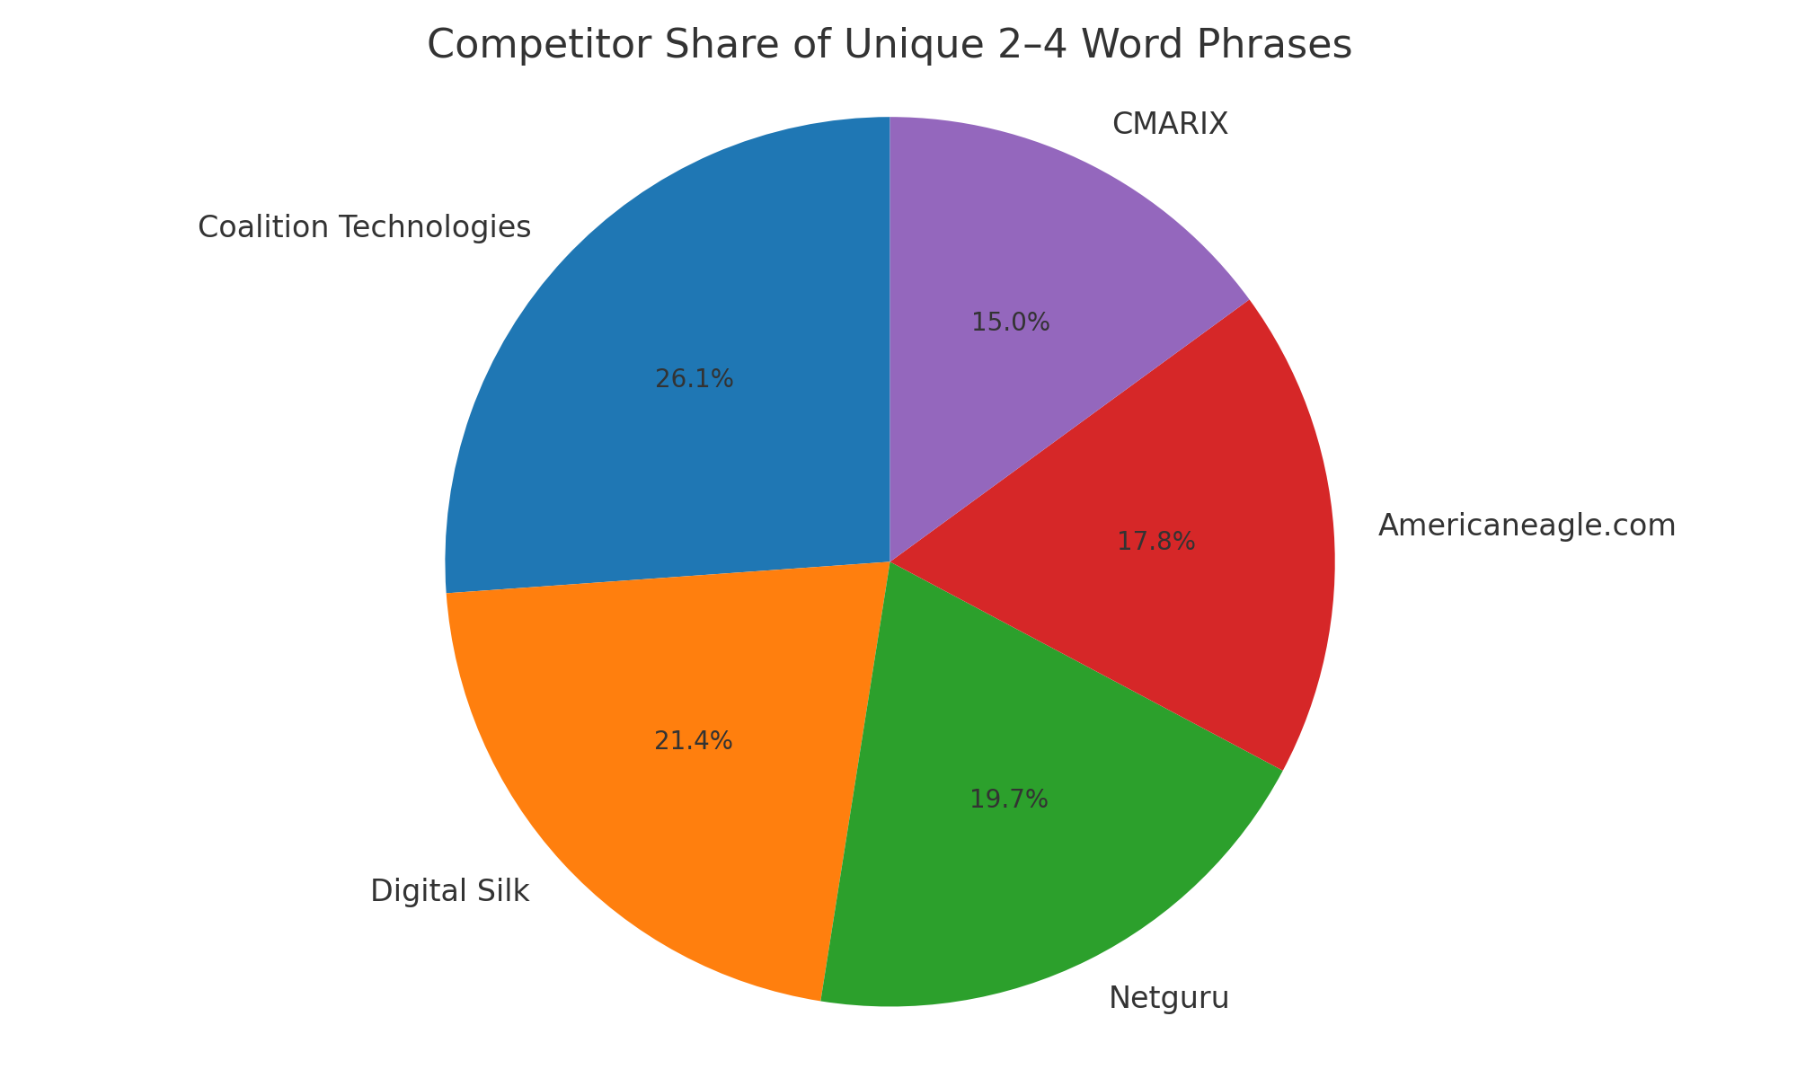

# 5. Tail-Type Distribution (Unique Phrases)

Counts of unique phrases by tail type across all competitors.

|  |  |
| --- | --- |
| Tail Type | Unique Phrases |
| Mid tail (3) | 139 |
| Short tail (2) | 137 |
| Long tail (4) | 136 |

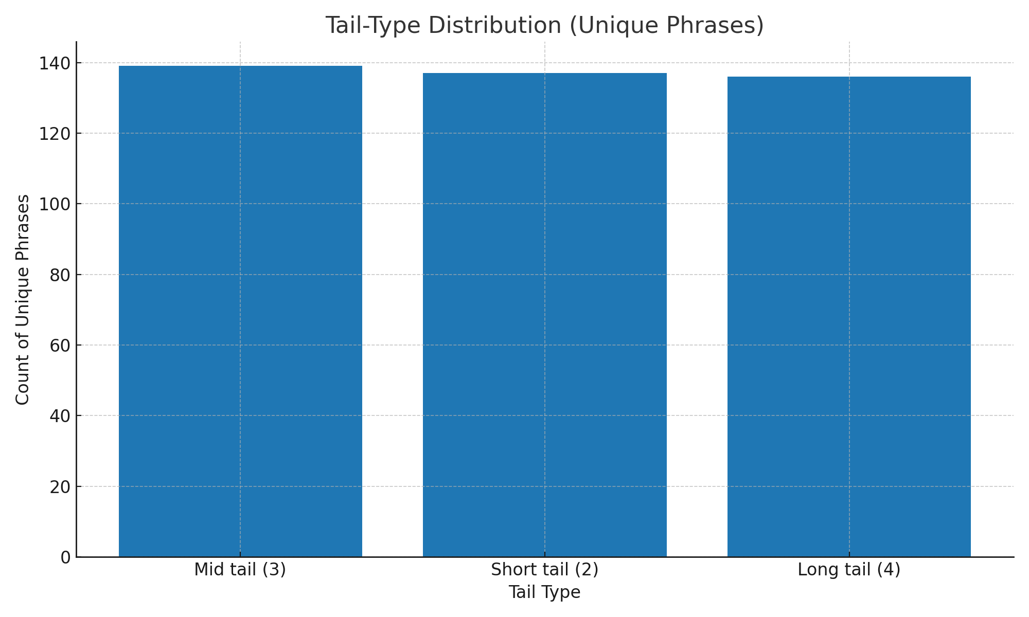

# 6. Tail-Type Distribution by Competitor (Unique Phrases)

|  |  |  |  |
| --- | --- | --- | --- |
| competitor | Long tail (4) | Mid tail (3) | Short tail (2) |
| Americaneagle.com | 24 | 25 | 26 |
| CMARIX | 20 | 21 | 22 |
| Coalition Technologies | 36 | 37 | 37 |
| Digital Silk | 29 | 30 | 31 |
| Netguru | 27 | 28 | 28 |

# 7. CPC vs Difficulty

Scatter plot of CPC (USD) vs Difficulty, with bubble size indicating the Volume Index. This helps identify keywords that are potentially cheaper yet easier (lower difficulty).

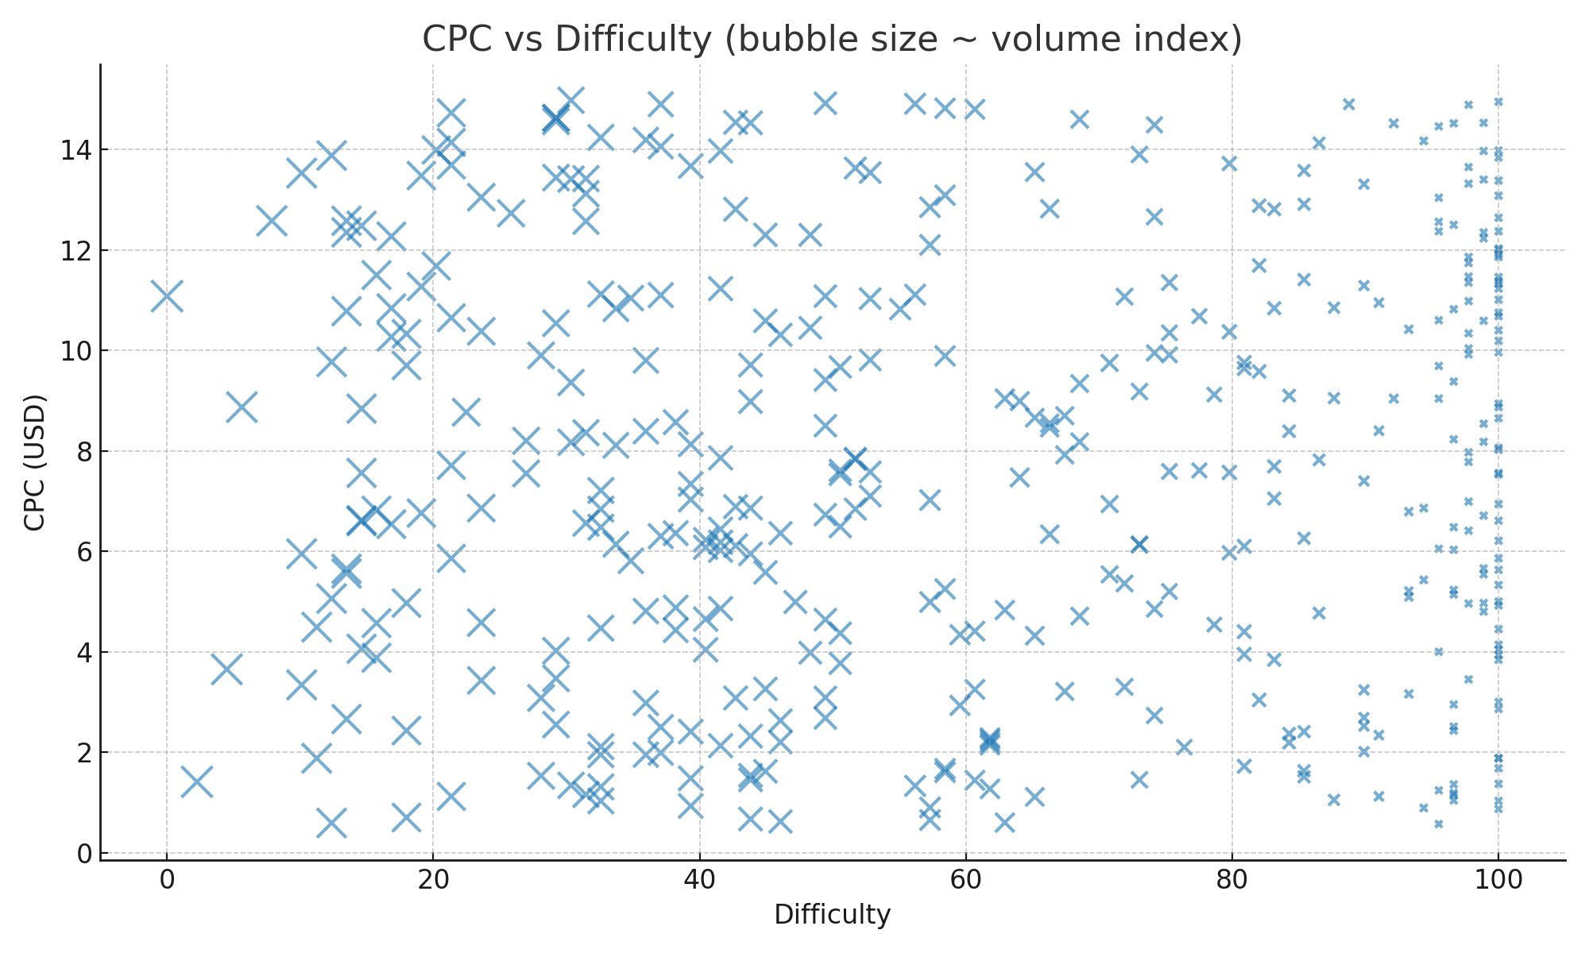

# 8. Top Keywords

Top 20 by Volume Index (average across duplicates):

|  |  |  |
| --- | --- | --- |
| Keyword | Volume Index | Difficulty |
| keep your | 89.0 | 0.0 |
| of your | 87.0 | 2.25 |
| at the | 85.0 | 4.49 |
| that drive | 84.0 | 5.62 |
| that keep | 82.0 | 7.87 |
| we create | 80.0 | 10.11 |
| that keep your | 80.0 | 10.11 |
| a high | 80.0 | 10.11 |
| business at the | 79.0 | 11.24 |
| uses the | 79.0 | 11.24 |
| cutting edge | 78.0 | 12.36 |
| that build | 78.0 | 12.36 |
| your business | 78.0 | 12.36 |
| team uses the | 77.0 | 13.48 |
| the forefront | 77.0 | 13.48 |
| that drives | 77.0 | 13.48 |
| websites that | 77.0 | 13.48 |
| that delight | 77.0 | 13.48 |
| creating digital | 76.0 | 14.61 |
| and complex | 76.0 | 14.61 |

Easiest 20 (lowest Difficulty):

|  |  |  |
| --- | --- | --- |
| Keyword | Difficulty | Volume Index |
| keep your | 0.0 | 89.0 |
| of your | 2.25 | 87.0 |
| at the | 4.49 | 85.0 |
| that drive | 5.62 | 84.0 |
| that keep | 7.87 | 82.0 |
| that keep your | 10.11 | 80.0 |
| we create | 10.11 | 80.0 |
| a high | 10.11 | 80.0 |
| uses the | 11.24 | 79.0 |
| business at the | 11.24 | 79.0 |
| your business | 12.36 | 78.0 |
| that build | 12.36 | 78.0 |
| cutting edge | 12.36 | 78.0 |
| that delight | 13.48 | 77.0 |
| the forefront | 13.48 | 77.0 |
| websites that | 13.48 | 77.0 |
| team uses the | 13.48 | 77.0 |
| that drives | 13.48 | 77.0 |
| your business at | 14.61 | 76.0 |
| at the forefront | 14.61 | 76.0 |

Top 20 by CPC:

|  |  |  |
| --- | --- | --- |
| Keyword | CPC (USD) | Volume Index |
| web and application development | 14.98 | 62.0 |
| corporate sites and complex | 14.95 | 0.0 |
| development services | 14.92 | 45.0 |
| that delight customers | 14.9 | 10.0 |
| company build a | 14.9 | 56.0 |
| custom websites built for | 14.89 | 2.0 |
| delight customers | 14.82 | 37.0 |
| and conversion | 14.8 | 35.0 |
| digital marketing | 14.73 | 70.0 |
| we create beautiful | 14.63 | 63.0 |
| and build | 14.63 | 63.0 |
| build industry | 14.6 | 28.0 |
| forefront of your | 14.56 | 63.0 |
| application development | 14.54 | 51.0 |
| leading web based products | 14.53 | 1.0 |
| development solutions | 14.53 | 50.0 |
| javascript development cms development | 14.52 | 3.0 |
| growth web and application | 14.52 | 7.0 |
| design digital marketing strategy | 14.49 | 23.0 |
| development solutions websites | 14.46 | 4.0 |

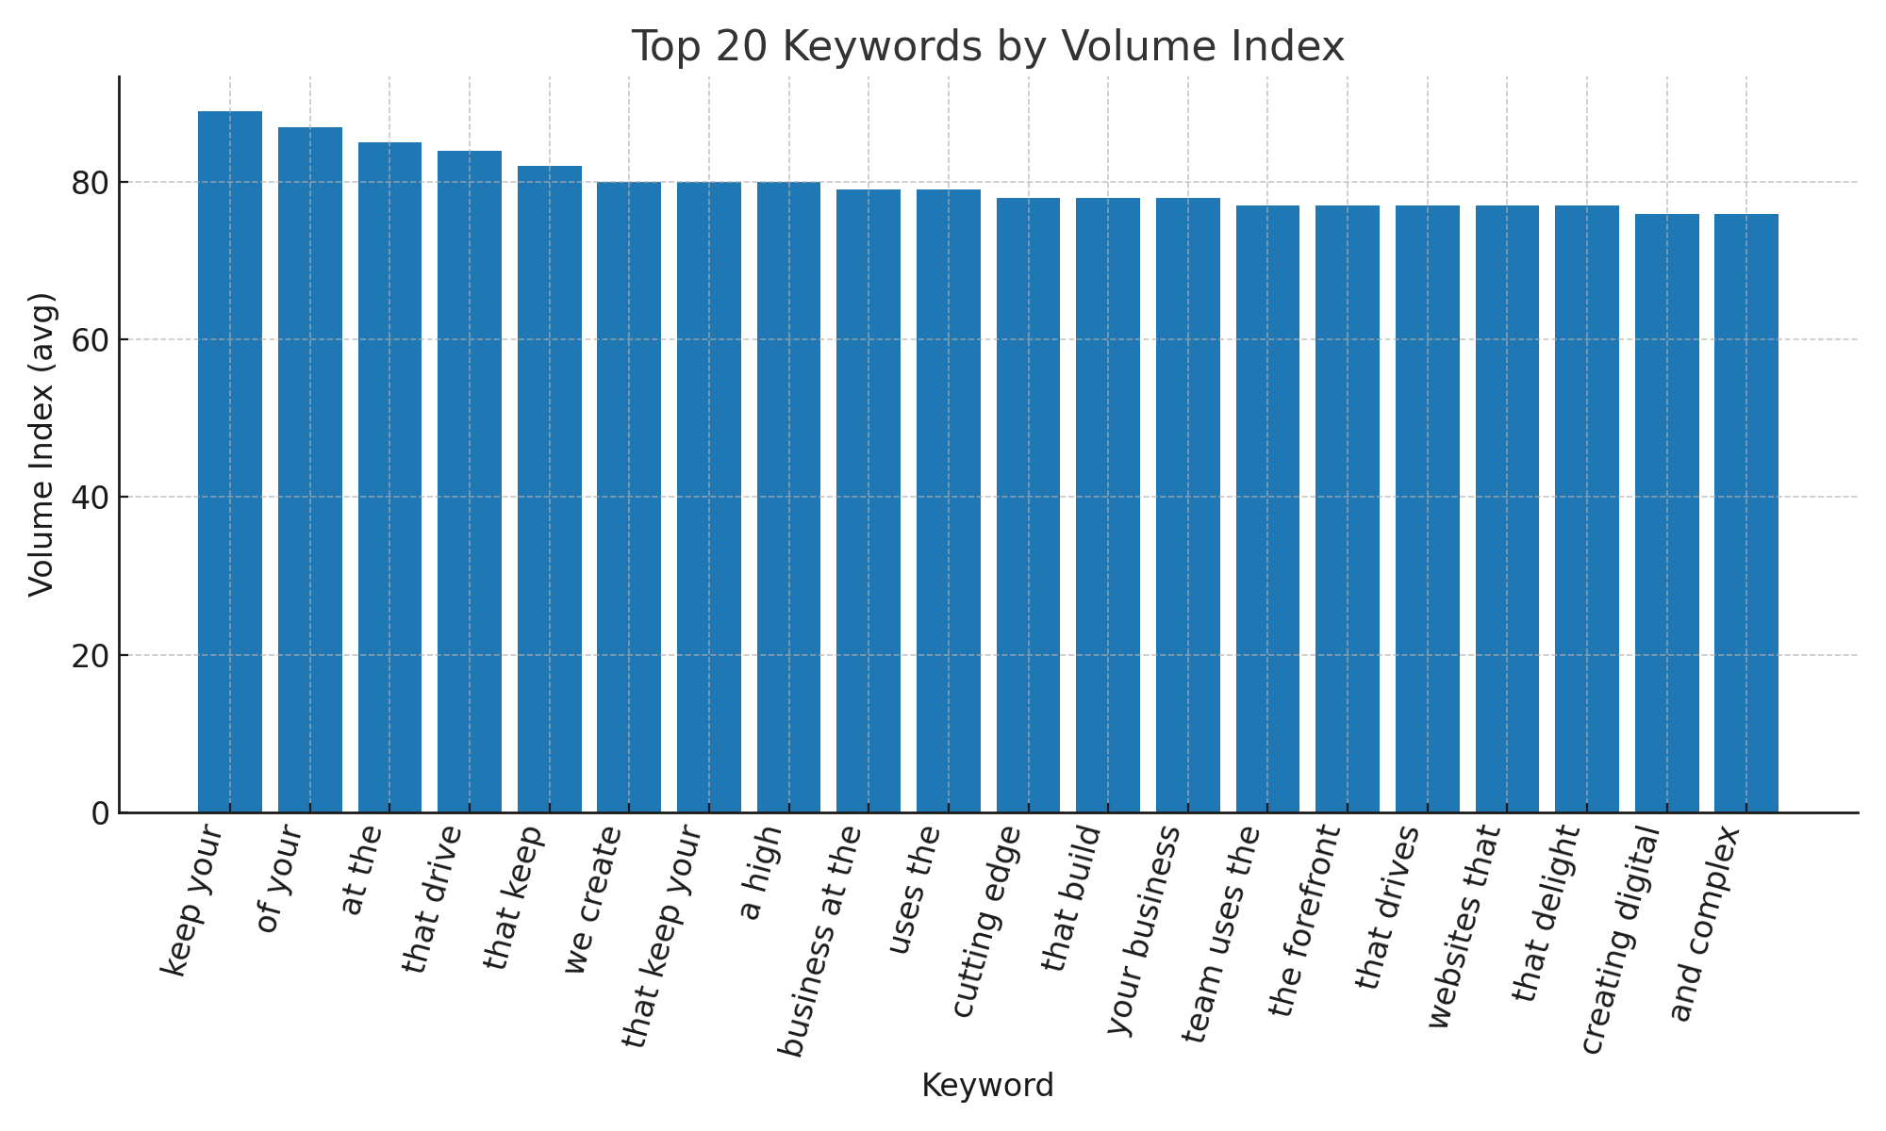

# 9. Observations & Recommendations

• Competitor coverage varies; those with higher share of unique phrases may have broader topical reach.  
• Balance between short and long-tail terms is important. Short tail can drive broad visibility, while long tail captures specific intent and often converts better.  
• Consider prioritizing keywords in the low-to-moderate difficulty band while monitoring CPC. Look for bubbles in the lower-left quadrant of the CPC vs Difficulty chart with reasonable volume.  
• Expand content sections (FAQs, use cases, industry pages) to generate more 3–4 word phrases aligned with intent.